National Forensic League
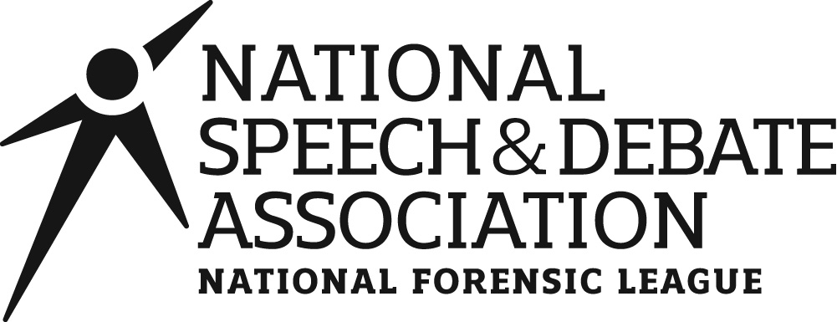dba National Speech & Debate Association
Image and Media Release

School Affiliation City State

IMAGE AND MEDIA RELEASE
In connection with my participation in events sponsored or run by the National Forensic League, I hereby expressly grant to the National Forensic League d/b/a National Speech & Debate Association and its affiliates and designees (collectively the “Association”) the irrevocable, perpetual, worldwide right and permission to make or record
video (or other digital media) images and recordings, audio and/or visual recordings or photographic images or likenesses of me in connection with my participation in any Association events and activities in which I participate, either in person or online/virtually, (the “Recordings”) and to use such Recordings as well as any materials I create, submit, or use in connection with or related to the Association or its events or activities (“Materials”) or any of portion of the Recordings and Materials, with or without alteration, alone or in conjunction with other images or elements of any type, in any manner (whether now known or later invented), by any means (whether now known or later invented), and in any and all media (whether now known or later invented), without restriction including, but not limited to, in any and all of the Association’s publications (including online/web based publications), promotions and advertising.

I acknowledge that the Association has no financial commitment or obligation to me as a result of this Image and Media Release (the “Release”) or the use of the rights granted in this Release. Additionally, I waive any right to royalties or other compensation arising out of or related to the use of Recordings or Materials.

I understand and agree that the Association and/or its authorized representatives shall have the exclusive right, title, and interest, including copyright, in and to the Recordings or Materials.

I hereby irrevocably release, forever discharge, and hold harmless the Association and its authorized representatives from any and all causes of action, claims, demands, damages, costs or expenses, including attorney’s fees, which relate to or arise out of any creation, development or use of these Recordings and Materials.

I have read and understand the Release and I agree to and accept its provisions. I affirm that I am at least 18 years of age, or, if I am under 18 years of age, I have obtained the required consent of my parents/legal guardians as evidenced by their signatures below. I Accept:

Student Name (PRINT) Signature of Student Date (mm/dd/yy)

If under 18, parent or legal guardian must sign.

I am the parent/legal guardian of the person signing the Release and I hereby ratify it and release all claims whatsoever which either I or above student may have with respect to the matters covered by the Release.

Parent/Guardian Name (PRINT) Signature of Parent/Guardian Date (mm/dd/yy)

It is the fundamental responsibility of the coach to acquire this signed form before the first day of competition and retain this signed form through December 31. Tournament officials may request this signed form at any point during and immediately following the competition.

updated 11/8/2022

