CREATING AN ACCOUNT IN TABROOM
Two Ways:
1.) You Have an NSDA Account (on the NSDA Side) But Are Not Listed as the Chapter Advisor and You Do Not Have a Tabroom Account
- Go to www.tabroom.com
- Click “Sign-Up”
- Use the right side of the page and enter your NSDA login (username and password)

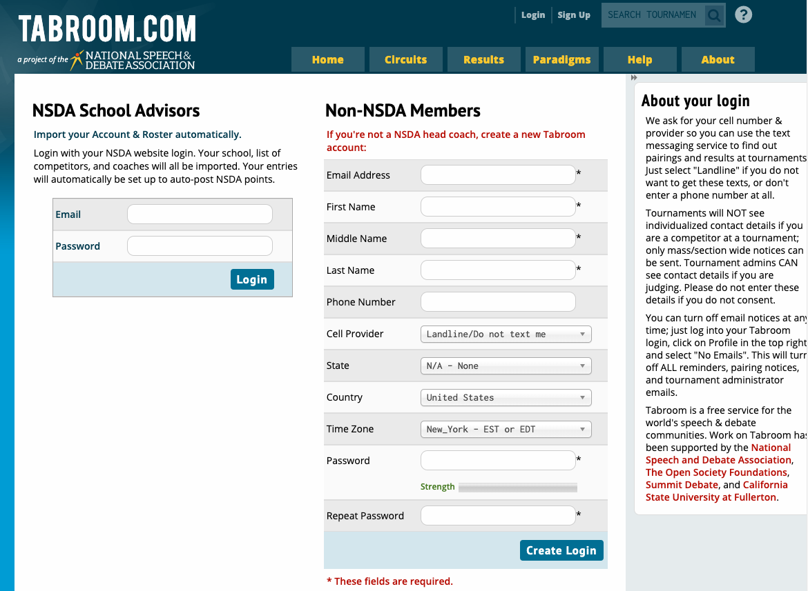

After clicking the “Create Login” button at the bottom, the system will then take you to this page:
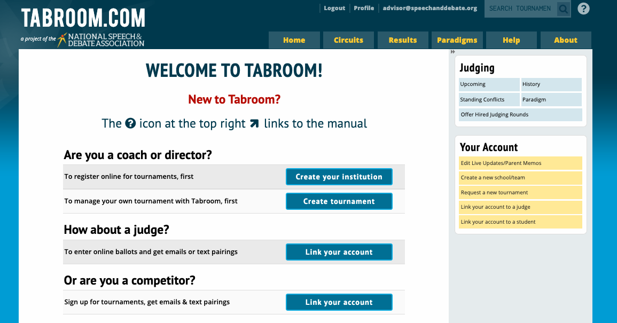

You can either click the appropriate button in the middle of the page or you can click the appropriate button of the right side of the page (yellow). Both sections do the same things. You want to get your account in Tabroom linked to a school so you will click “Create Your Institution” (blue button) or “Create a New School/Team (in yellow).
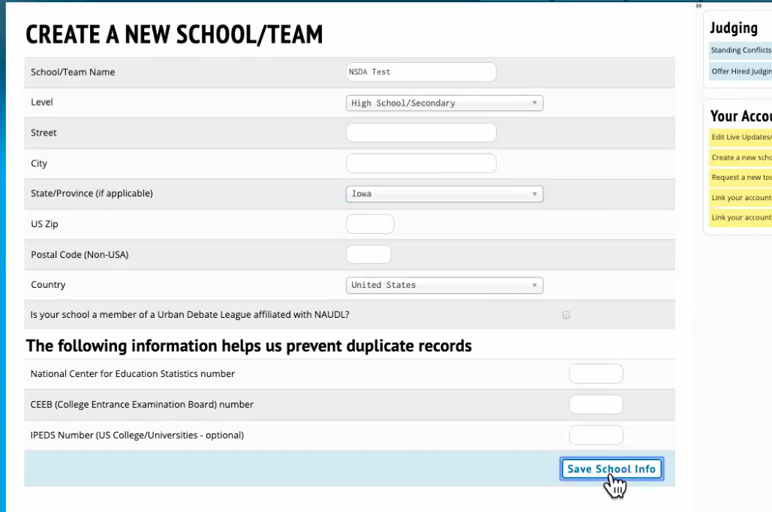

Clicking the button will bring up something like this below. Pay close attention to the name of the school the system found and the “Accounts w/ Access” as those are the Chapter Advisors for this school and if those look familiar to you, you should not go to the bottom section and create another new school. You should reach out to those people listed and see if you can be added to Tabroom so you can have access.
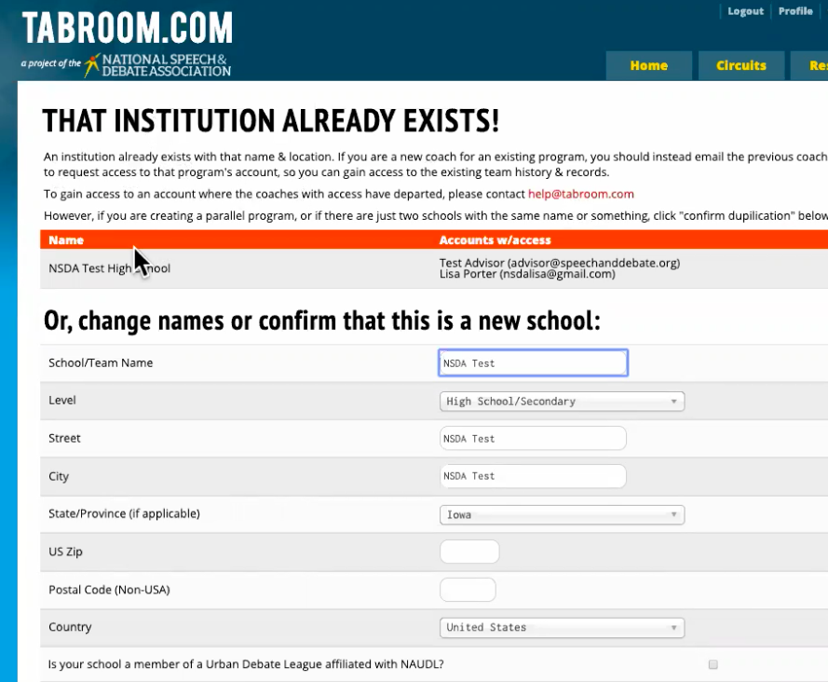

2.) You Have an NSDA Account as the Chapter Advisor but no Tabroom account:
- Go to www.tabroom.com
- Click “Sign-Up
- Use the left side of the page and enter your NSDA login (username and password)

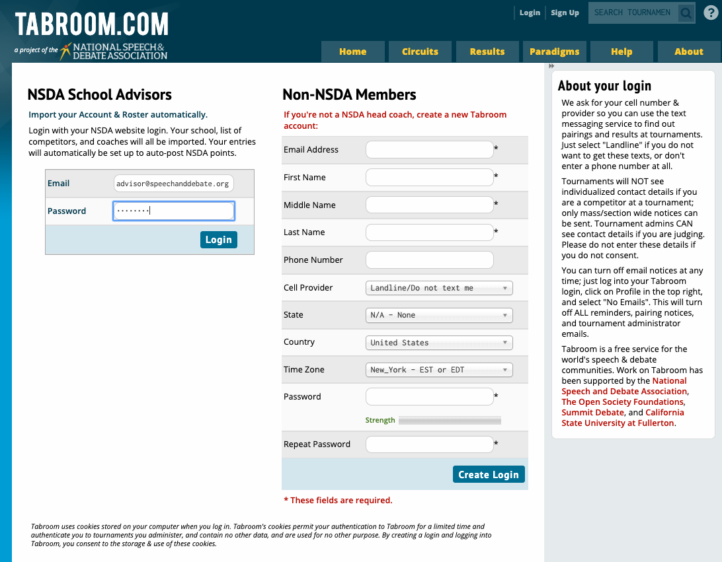

After clicking the “Login” button you will see this screen come up because Tabroom sees that your NSDA account is connected to a school and you can click the “Import” button:
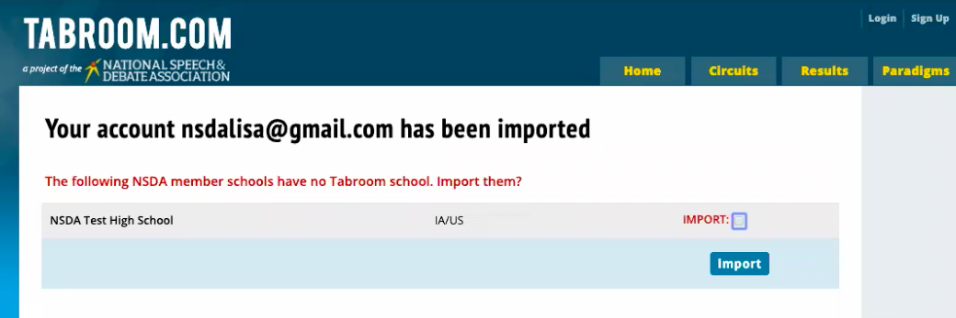

Once you click the “Import” button, it moves the students to your school now created in Tabroom and any coaches listed are now listed as judges on the judges tab. The program tells you that the school was successfully imported into Tabroom.
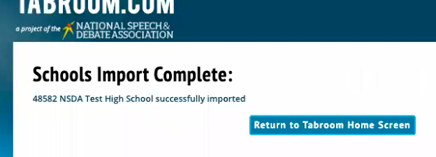

-----------------------------------------------------------------------------------------------------------------------------

GETTING YOUR ROSTER ON THE NSDA SIDE CONNECTED TO YOUR ACCOUNT IN TABROOM:

Remember, if you get lost in Tabroom, you can always click your email at the top of the page which will take you to the main page which shows you the tournaments.

Click on your school under institutions. If you have more than one school listed, make sure you click the correct school you want to work with.

Click the “Competitors” tab. From the “Competitors” tab there are several buttons on the right menu you can work with. Remember, you have to be on the “Competitors” tab to see these buttons.
- “Import NSDA Competitor Roster” button:
  - Click this button if you have students who are listed on the NSDA side, but you are not seeing these students on the “Competitors” tab in Tabroom.
    - Current Roster in Tabroom (from the “Competitors” tab):
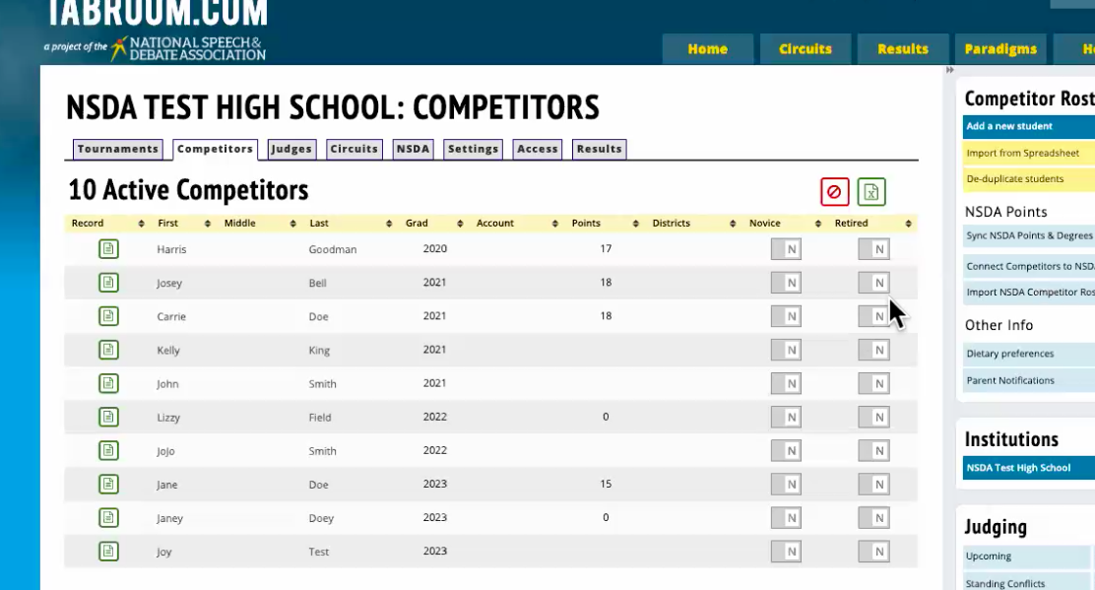

    - What I see after clicking “Import NSDA Competitor Roster”:
(these 2 students are on the NSDA side but not listed in Tabroom yet)
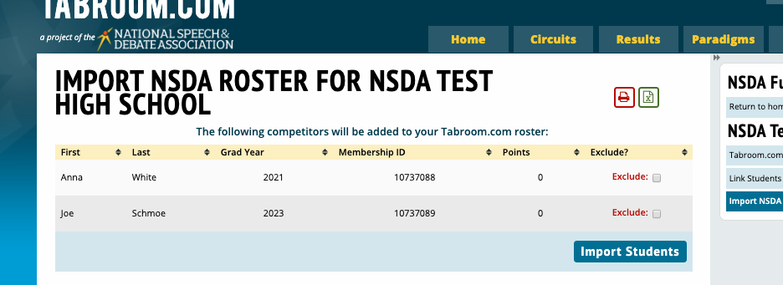

    - Click “Import Students” and this is what I see:
(now my roster shows those two students)
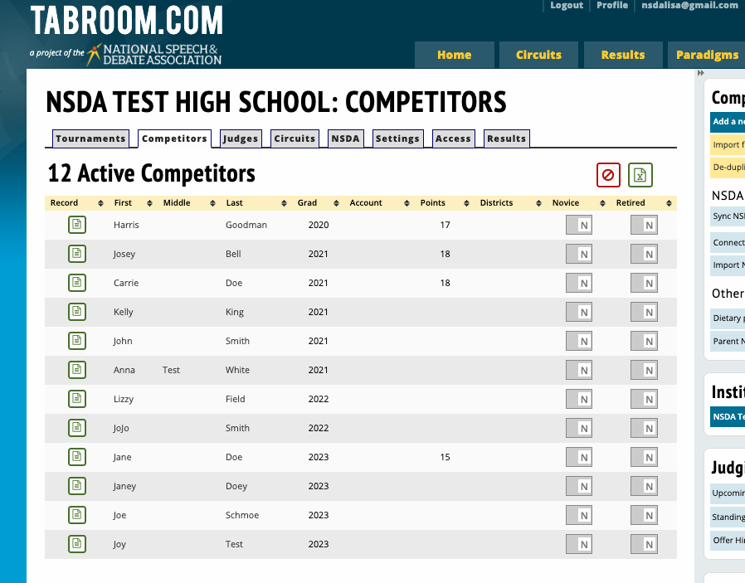

- “De-Duplicate Students”:
  - In Tabroom, if you manually add a student to tabroom, by clicking the “Add a new student”, from the menu on the right, please remember that the student you add to Tabroom is not connected to the same student you might already have listed on the NSDA side. When you click the “Import NSDA Competitor Roster” button, there might be two students listed with the same name or similar names because the manually entered student and the student imported from the NSDA side will be listed.
    - You should correct the name that is not listed the way the name is listed on the NSDA side and save. You do this by clicking on their name from the “Competitors” tab, in Tabroom, making the change and then saving. Once you have done so, click the “De-duplicate students” button to merge the two together. Please note that you might have to correct the name spelling as well as the grad year.
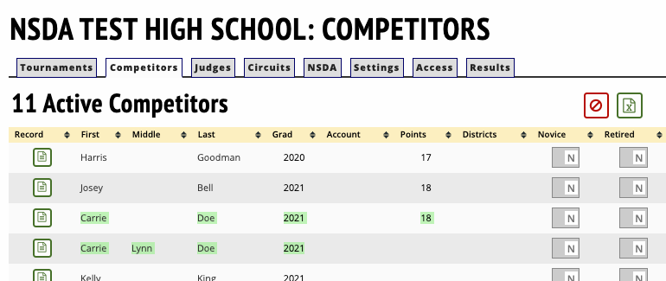

    - After taking out “Lynn” and saving, the two students now show up when I click “De-duplicate” and the “Merge Duplicates” should be clicked so that the two records will be merged into one.
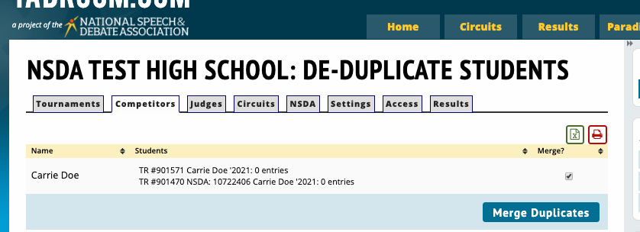

- “Connect Competitors to NSDA Memberships”:
  - When you click this button, there could be two sections, “Match Unlinked Tabroom Competitors” and “Competitors Already Linked”. Any unmatched students with the correct person in the drop down that the system choses should be confirmed that it is matching the correct student and then the “Link Students” button should be clicked. This links the students from the NSDA side to Tabroom.
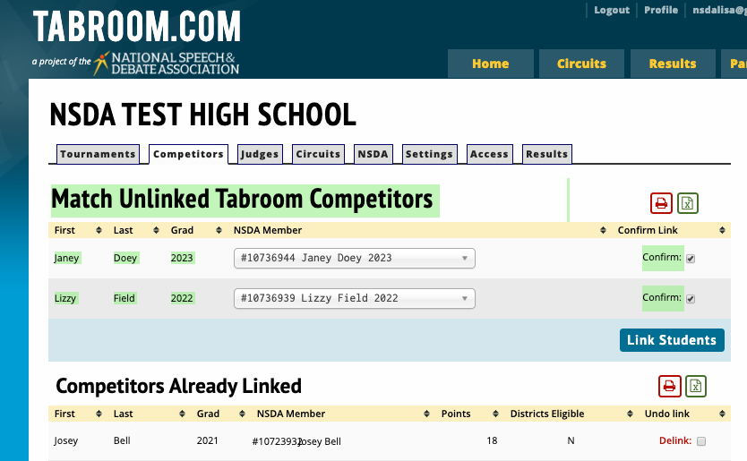
  - If there are no unmatched students, then nothing needs to be done here because you won’t see a section called “Match Unlinked Tabroom Competitors”.
- “Sync NSDA Points & Degrees”:
  - From the “Competitors” tab, clicking this button will fix/connect/confirm students with their points and degrees.

