Starting Word Search:

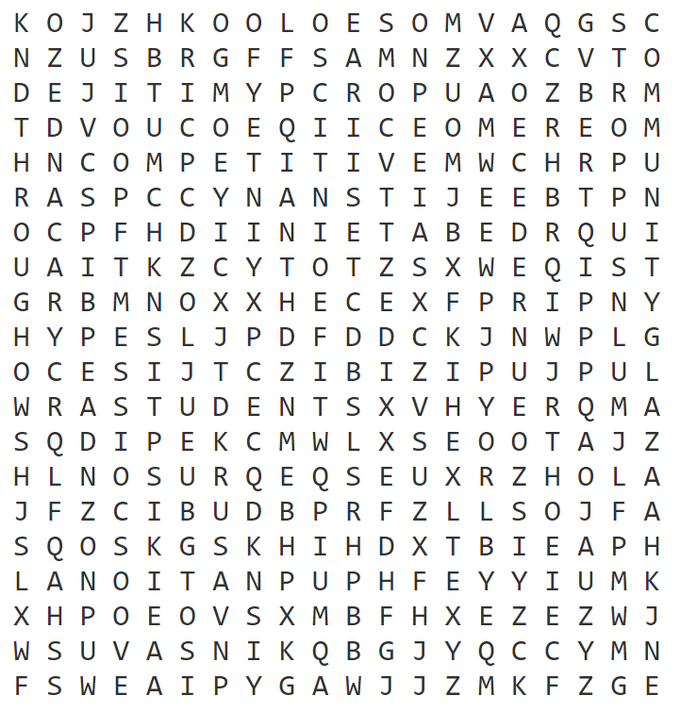

Provided to the National Speech & Debate Association courtesy of Dan Hansen and Becky Hansen, Fort Atkinson High School, WI

Instructions: The word search has all the words contained in the NSDA mission statement:

The National Speech & Debate Association connects, supports, and inspires a diverse community committed to empowering students through competitive speech and debate.

We created a fill in the blank with each letter kind of code. For example, the first two words might be listed as - H - - A - - - N - - (the words “the” and “national” go there). We would then circle one of the blanks as a key letter. Once students have found all the key letters, they spell out a word, although not necessarily in the order they were found. This year, since the topic was arms sales, we had students find four key letters: “S” “A” “L” and “E.” It was interesting that students first tried SEAL and ALES before thinking about the topic. They got there eventually.

Word List:

AND
ASSOCIATION
COMMITTED
COMMUNITY
COMPETITIVE
CONNECTS
DEBATE
DIVERSE
EMPOWERING
INSPIRES
NATIONAL
SPEECH
STUDENTS
SUPPORTS
THE
THROUGH

Website used: http://puzzlemaker.discoveryeducation.com/code/BuildWordSearch.asp

Provided to the National Speech & Debate Association, courtesy of Dan Hansen and Becky Hansen, Fort Atkinson High School, WI

