The Anatomy of a Debate Tournament Handout #4

Purpose of a Tournament
Debaters attend tournament competitions at other schools in order to test the skills we have learned in practice. Tournaments allow you to compete against other students from Georgia and the United States. Debate tournaments are very fun; however, they are more like a business trip than a family vacation. While we will always have time spent enjoying ourselves as a team, the majority of the daytime hours will be spent participating in debates.

Schedule
There are three general schedules for tournaments that first year (novice) debaters attend:
*Please note- these are merely examples, modify these to fit your region

One Day Local Tournaments
One day local tournaments take place on Saturdays. They usually feature four rounds of debate. Each team will participate in all four of these rounds, alternating affirmative and negative so that each team is affirmative twice and negative twice. For example, a team might be affirmative in rounds one and three and negative in rounds two and four. An awards assembly will follow round four. Some of these tournaments also have a final exhibition round for the top two teams in each division, determined by teams’ records

Example — One Day Local Tournament:
7:30-8:30AM Registration
8:45-9:00AM Assembly
9:00-11:00AM Round 1
11:00-1:00PM Round 2
1:00-2:00PM Lunch
2:00-4:00PM Round 3
4:00-6:00PM Round 4
6:30PM Awards

Two Day Local Tournaments
Two day local tournaments take place on Friday evenings and all day Saturday. They usually feature between four and six preliminary rounds. Based on a team’s record, they may then advance to the elimination rounds; like a tournament in most sports, elimination rounds feature the top X number of teams with the highest seed debating the lowest seed (and so forth). Teams usually flip for sides before the debate and the loser is eliminated from the tournament. There will be an awards assembly on Saturday, usually before the final elimination rounds.

The Anatomy of a Debate Tournament Handout #4

Example — Two Day Local Tournament:
Friday
3:15 -3:45 Registration in Media Center
4:15 Round 1
6:00 Dinner Break
6:30 Round 2
8:25 Round 3
Saturday
8:00 Round 4
10:00 Round 5
12:00 Lunch Break
12:45 First Elim Round
2:45 Second Elim Round
4:45 Awards

Multiple Day National Tournaments
Occasionally novices will have the opportunity to attend tournaments outside of Georgia. Due to travel time, these tournaments usually last several days. They are very similar to the two day local tournaments except that they may feature more debates.

Example — National/Regional Tournament:
Friday
11:00AM Depart School by bus
1:00-3:00PM Registration (coach only)
3:45-5:30PM Round 1
5:30-7:30PM Round 2
8:30-10:30PM Round 3

Saturday
7:45-9:30PM Round 4
11:00-1:00PM Round 5
2:00-3:30PM Round 6
4:00PM Awards
4:30-6:00PM Elimination Rounds
6:30-8:00PM Elimination Rounds
8:30-10:00PM Elimination Rounds

Sunday
9:00AM Return to School by Bus

The Anatomy of a Debate Tournament Handout #4

The Novice Division
The novice division is for first-year debaters only (although it may include second-year debaters with very minimal experience). Therefore, the playing field is very level — you will not have to worry about debating an experienced varsity team. In Georgia, novice tournaments feature limited topic areas that confine teams to the arguments contained in the packet. This helps debaters better prepare for debates and encourages more clash. At some novice tournaments in other states, however, the novice division does not feature a case list. If you attend one of those tournaments, you will have to be prepared to debate any topical affirmative case.

Pairings
Before each debate, the tournament will release “pairings” or “schematics” which tell you who you are debating against, whether you will be affirmative or negative, who will judge the debate, and where the debate will take place. They are released between ten and thirty minutes before the debate. When the pairing comes out, you should go to your assigned room and prepare for your debate

SAMPLE DEBATE PAIRING

Room Affirmative Negative Judge
A116 Chattahoochee KK Alpharetta TW Gibson
A120 Johns Creek RS Marist AV Jordan
A114 Northview CH Johns Creek BJ Miller
A110 Westminster SW Chattahoochee KL Spiegel
A122 Marist EZ Alpharetta ES Batterman
A118 Carrollton BH Pace Academy HT Schirmer
A128 Marist MS Fayette County RL Grellinger

The Anatomy of a Debate Tournament Handout #4

Ballots
For each debate that you participate in, you will get a ballot that indicates the winner and loser and how many speaker points are awarded to each debater. Points are awarded on a 30 point scale based on the overall skill of the debaters, not necessarily the differential between the two teams. Points are not used to keep score; they are used to communicate how well the judge thought you performed above and beyond the decision. In fact, a team can win with fewer points than the losing team if they have done an overall better job but lost a critical argument.

Here is an example ballot that shows that the affirmative from Pace Academy won the debate versus the negative from Lexington High School in Massachusetts:
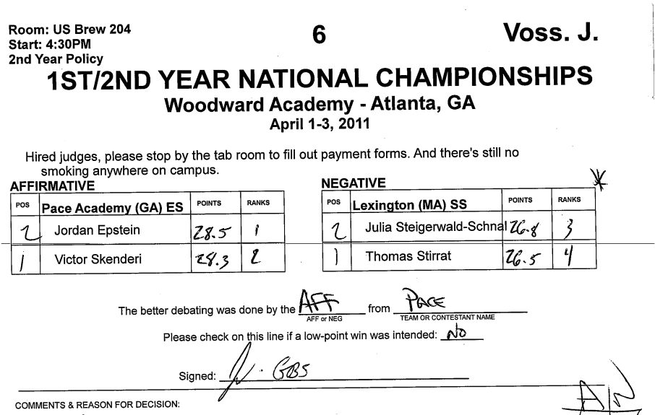

Awards
At the end of the tournament there will be an awards assembly. Students earn team awards based on their win-loss record in the tournament. Students earn speaker awards based on their speaker points in the debates, not wins and losses. Students who participate in elimination rounds will typically receive awards for their performance.

While we are always excited to see Woodward debaters do well, it is important to remember that respectful competition requires politely clapping for our teammates, not cheering or yelling when they receive awards.

It is expected that debaters stand to applaud the top speaker and champion in each division.

