How to Register for Districts on Tabroom

First, check eligibility.

- SCHOOL MEMBERSHIP: Check that your school is currently a member by logging into www.speechanddebate.org/account. Click “School Profile” and look for the blue checkmark next to “Active”. Pay for membership on the “School Finances” tab.
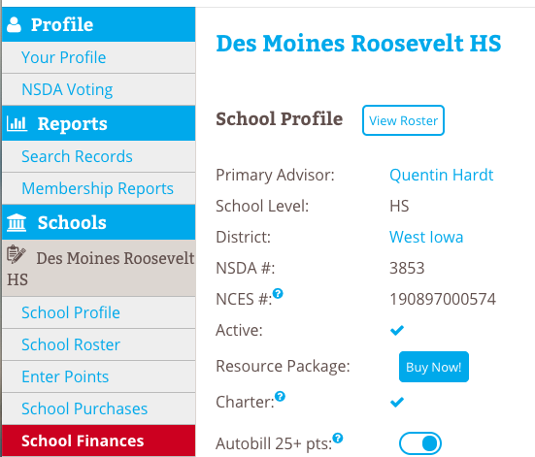

- STUDENT MEMBERSHIP: All students that compete at the district tournament must be paid student members with a minimum of 25 points. Go to www.speechanddebate.org/account and click “School Roster”. Students must have blue checkmarks in the “Member” column, more than 25 points in the “Points” column, and a username/password linked in the “Account” column. Add new students using the button at the top of the page, and pay their memberships on the “School Finances” tab. A blue checkmark under “districts eligible” will appear when a student is eligible.
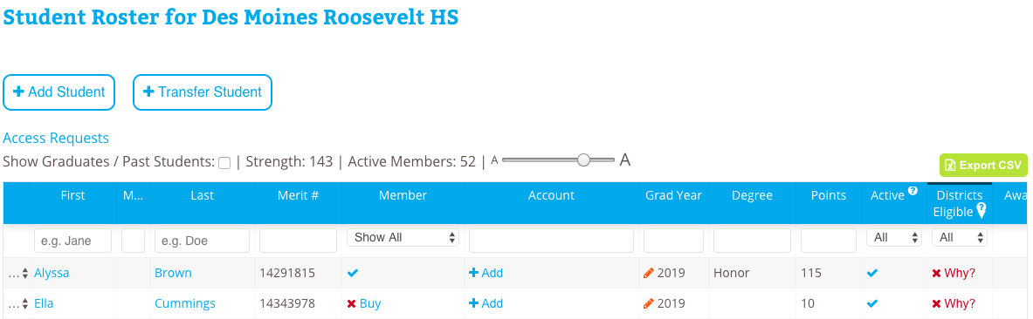

Student A
Student B

Student A needs an NSDA account
Student B needs membership, an NSDA account, and 15 more points to be eligible

Next, sync your roster to Tabroom.

- Login to tabroom.com. Click your email in the upper right corner, and then click your school name under “Institutions”. Go to the “Settings” tab. Make sure your NSDA School ID number is filled in. If not, this can be found on your school profile page at http://www.speechanddebate.org/account (see #1 on page prior). Save chapter details.
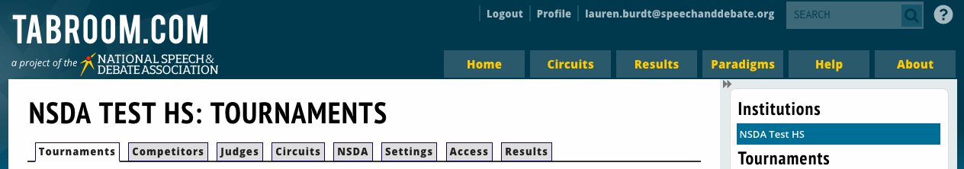
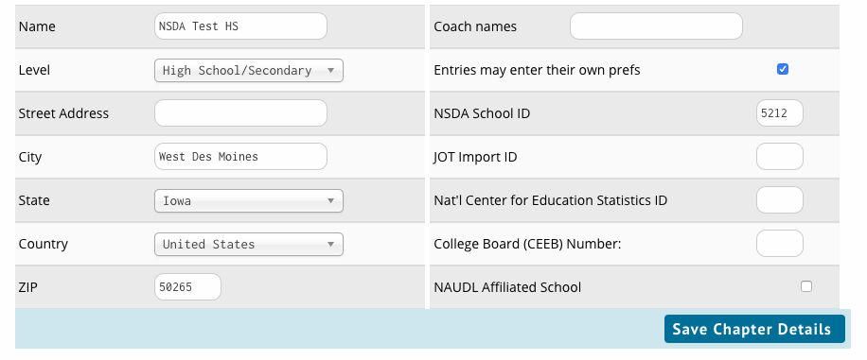

- Go to the “Competitors” tab. Click “Import NSDA competitor roster” on the right side of the page under “NSDA Points”. A list of competitors may show up. Click “Import students” at the bottom of the page. Your Tabroom roster is now synced with your NSDA account.

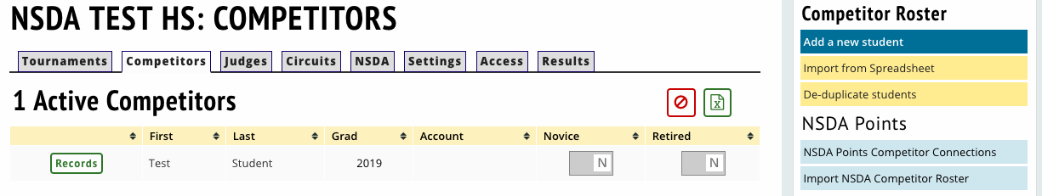
Add judges to your Tabroom roster.

- Click the “Judges” tab. Click “Add new judge” on the right side. If your judge has a Tabroom account, search for their email. If not, enter their information. “Save judge” at the bottom of the page.
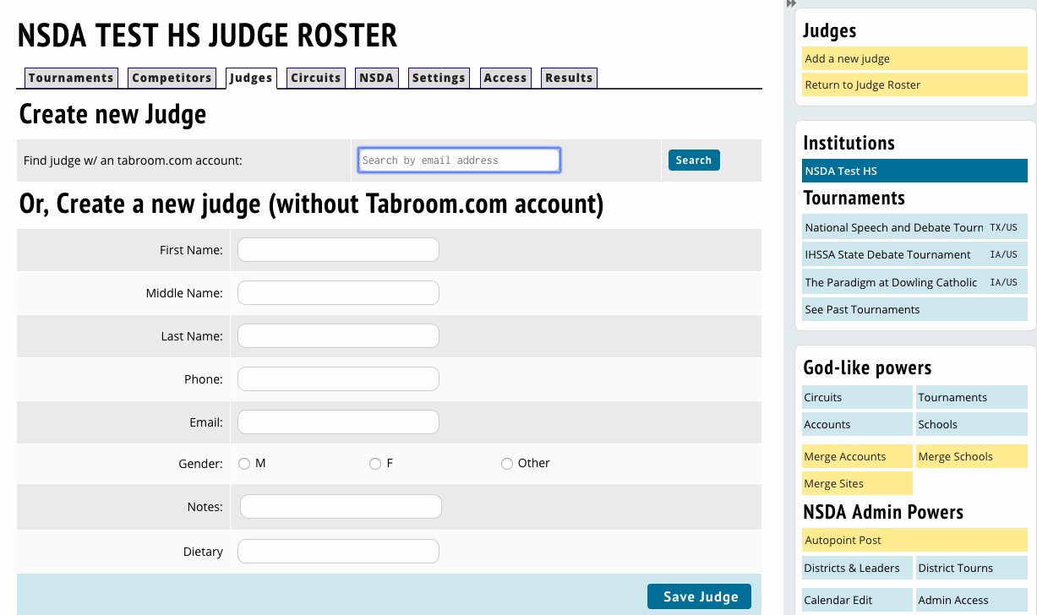

Now, register your students for the tournament.

- Go to the “NSDA” tab. Make sure “District” is selected in the top right corner. Click “Register for Districts” and accept the disclaimer.
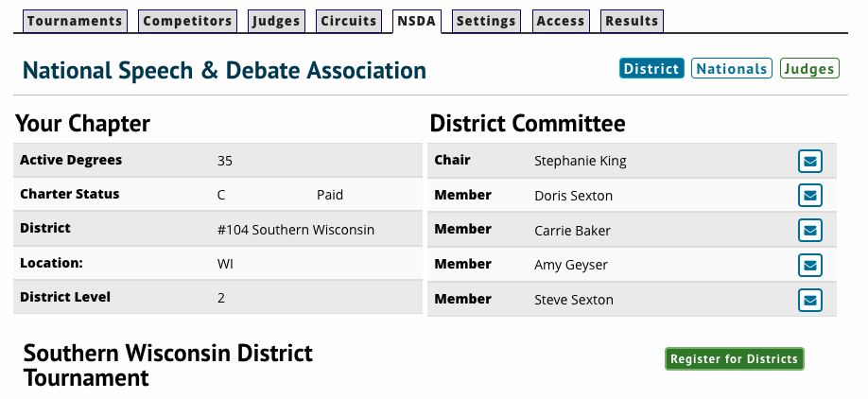

- A Districts Competitor Eligibility report will appear. If a student is not marked as eligible and should be, please view our troubleshooting tips. Click “Continue to registration”.
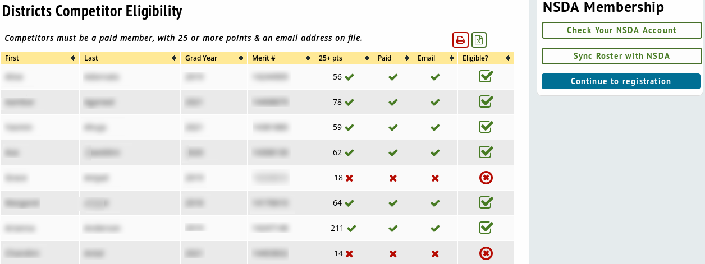
- Accept the disclaimer. Enter your contact information and click Save. Go to the “Entries” tab. First, select an event from the dropdown menu on the right side. Then select the student entry name. Click “Add entry” and repeat the process for each entry.

If you are missing a student from the dropdown menu, click “Check NSDA eligibility”. This will take you back to the eligibility report to see the problem. View troubleshooting tips here.
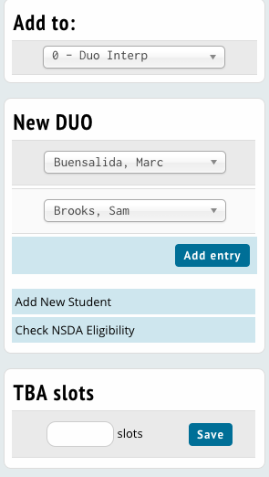

- Click the blue and white edit button next to an entry’s name and select “Piece/Title Info” if you need to enter speech details.
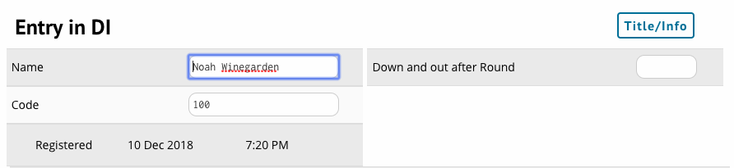

Fill out the required forms for the tournament.

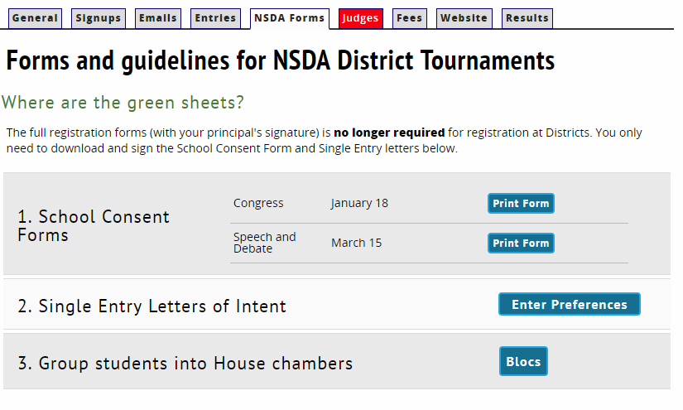
- Click the “NSDA Forms” tab. Click “Print form” next to the appropriate tournament date next to School Consent Forms. This will allow you to sign the consent form and bring it to your district tournament. These do not need to be mailed to the national office.

- Click “Enter preferences” next to Single Entry Letters of Intent. List your students’ event preferences in order. Note that there are requirements, namely surrounding partner events. Read those requirements here. Click “Save Preferences” when finished. This is required if you have students double entered. Auto-qualifiers must fill out the PDF form and turn it in to the district chair. Click “download” to download the PDF form.

- (Optional) If you have Congress entries, your District Committee may choose to let you choose which students go in which chamber. Click “Blocs” next to “Group students into chamber” to select each student’s chamber.

Enter your judges for the tournament.

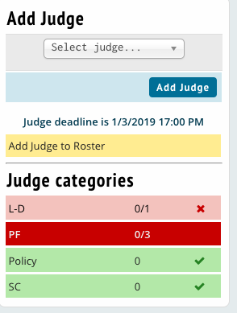
- Go to the “Judges” tab. The number of judges you owe will show up on the right side of the screen. Click a judge category to enter a judge in that category. Choose the appropriate judge from the dropdown menu and select “add judge”.

- You can also add a new judge to your roster. Please note that you will need to click the “tournaments” tab, select “entry” next to your district tournament, then click “judges” to get back to the judge screen.

Completing your districts registration.

- Click the fees tab to view your entry fees, and follow up with your district’s process to complete payment.

- Double check the entries and judges tab to ensure everything is correct. If you need to make changes later, click your email in the upper right corner and then click “entry” next to your district tournament name.

- Check with your district chair if you have any further questions or email info@speechanddebate.org.

