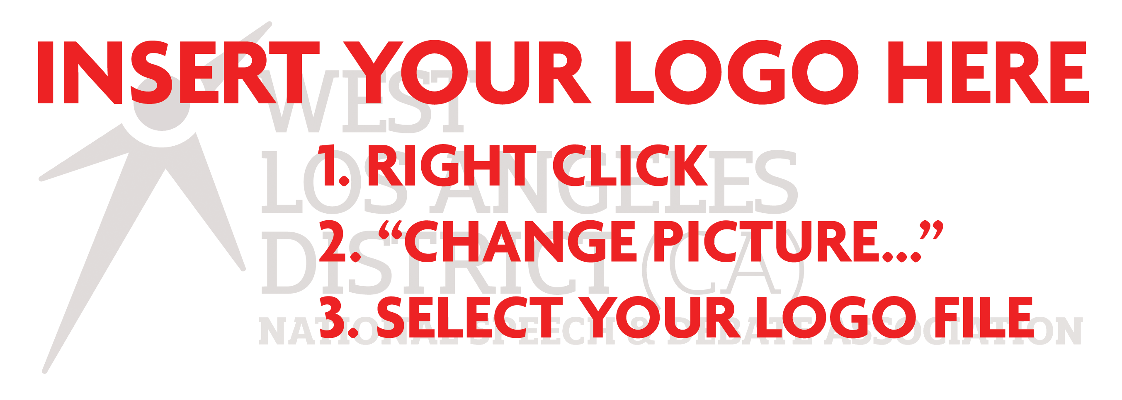
Please join us in welcoming our new members to the National Speech & Debate Association Honor Society!
Please join us in welcoming our new members to the National Speech & Debate Association Honor Society!
[XXXXday], [Month XX, 2026] at [00:00] p.m.
[Insert location here]
[Address, if applicable]
RSVP no later than [Month XX, 2026]
by contacting [Name]
[Contact Information]
Attire: [Insert “formal” or “business casual” here]

The [Blank] High School
Speech and Debate Team
Cordially invites you to be a guest at
their Honor Society Induction Ceremony

[XXXXday], [Month XX, 2026] at [00:00] p.m.
[Insert location here]
[Address, if applicable]
RSVP no later than [Month XX, 2026]
by contacting [Name]
[Contact Information]
Attire: [Insert “formal” or “business casual” here]

The [Blank] High School
Speech and Debate Team
Cordially invites you to be a guest at
their Honor Society Induction Ceremony

