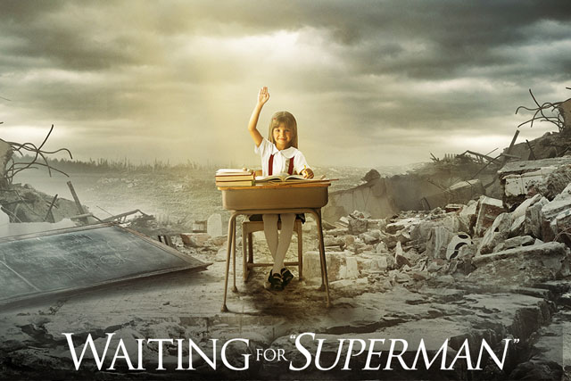

VIEWING QUESTIONS

Name_____________________ Block ______

**Before watching the video:**

What is your vision of a great public school? What are the key characteristics of a great school?

**While watching the video:**

1. How could charter and non-charter schools learn from one another?
2. How do we support teachers in their early years and enable good teachers to gain the confidence and experience to become great?
3. What do you think are the essential skills that a young person needs to prepare for a full and productive life after high school?
4. What is one of the problems the film identifies between federal government and state government in terms of education?
5. The US had the best education system in the world up until 1970. What changed then?
6. Name one entity/group/phenomenon that the film “blames” for the flaws in America’s educational system. Explain why the film places blame there.

**After watching the video:**

Several major stories are presented in the film: the history of public education in America, and the stories of individual children and families striving for the best possible education. Which story or stories touched you the most?

In the film, we see several examples of schools characterized by a culture of low expectations and low achievement. Are there schools in your community that fit this description? What do you believe are the root causes of these chronically low-performing schools? What is being done to improve them? What should be done?